CI Generator Simulation

Institute: IIT Guwahati
Student Name: Sarvesh Shashank Jadhav
Roll No: 240151018
Guide: Prof. Vinayak Kulkarni
Course: EN 202(Monsoon Semester 2025)
Github Link

Introduction
Objective:
To simulate the physical movement and working of a Single 4-stroke CI Generator to an elementary degree using MATLAB (ver. R2024b).
Outputs Acquired:
- Average Instantaneous Power Generated.
- Simulated Motion of Flywheel-Crankpin-Connecting Rod – Piston assembly.
- Graphs of various physical quantities related to the assembly and the generator over a 120 second time frame.
Scope:
To replicate the kinematic and dynamic behaviour of the Flywheel-Crankpin-Connecting Rod – Piston assembly and evaluate the basic performance parameters under user specified construction conditions and rotational speed of flywheel.
Simulation of Combustion Kinematics, Heat transfer, Mechanical to Electrical Power Conversion and Intake-Exhaust Processes of the assembly are outside the scope of this project.
Working Principle:
The simulation operates by linking a prescribed rotational motion of the flywheel to the kinematic motion of the crank–connecting rod–piston assembly. The angular position of the flywheel drives the combustion pressure pulse generator, which applies a corresponding force on the piston through the translational interface. This mechanical coupling allows the system to replicate the basic dynamic response of a real 4-stroke CI engine under variable torque conditions.

System Description & Analysis
The model consists of 3 main sub-systems (2 of these are formally made into subsystems in the model, with one not being made into one for convenience)
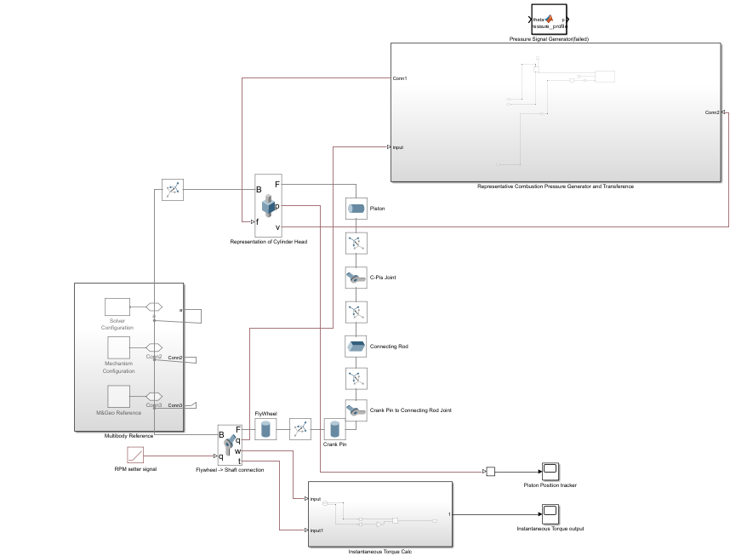
Figure 1: Overall Block Diagram Of the model.
The sub systems are:
- Multibody Assembly of Flywheel-Crankpin-Connecting Rod – Piston assembly.
- Representative Combustion Pressure Generator and Transference.
- Instantaneous Torque calculator
Further, an initialization script which runs on opening the project to create a struct(Engine) via a .mat file is used to take inputs for almost every aspect of the simulation. The script also checks if the inputs fulfill the Grashof condition only.
A .ssc script for the custom block Combustion Pressure Source is present.
Description of Subsystems
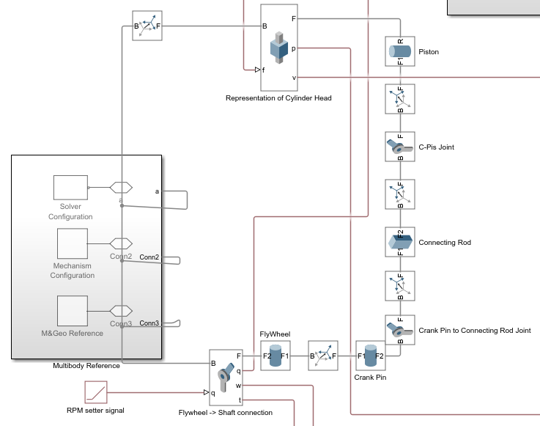
1. Multibody Assembly
Figure 2: Block Diagram of the Multibody Assembly
The important components of this sub-system are the following:
Flywheel ->Shaft connection
This component connects the flywheel (Follower) to the Multibody Reference (Base), essentially grounding it. It takes input from the RPM setter signal in rad/sec to fix a angular velocity [can be changed using the Engine.rotation variable in the initialization script] of the flywheel. Its sense is turned on for the Actuation torque and angular velocity which are later used to calculate the instantaneous power output as a function of time. The position sense is also turned on to give input to the Pressure Signal Generator block in the 2nd subsystem.

Representation of Cylinder Head
This component is a Prismatic joint which is constrained to only move along the global Z axis. It connects the Piston (Base) to the Multibody Reference (Follower), effectively acting as an approximation for the constraints given by the cylinder head. It takes Force input from the 2nd subsystem which is applied on the piston directly. It’s velocity also acts as a reference for the Interface in the same subsystem. Position sensing is also turned on and connected to a scope (off current frame) to verify the motion of the piston.

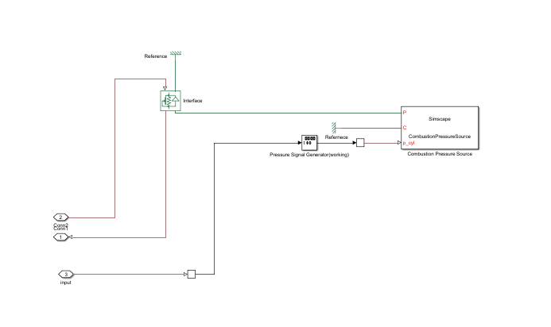
2.Representative Combustion Pressure Generator and Transference.
Figure 3: Block diagram of Subsystem 2
Interface
Converts the Mechanical signal from the Combustion Pressure Source to a Multibody PS signal to be given as input to the 1st Subsystem.
Pressure Signal Generator(working)
Takes the angular position from the flywheel revolute joint and gives output signal of a sawtooth pulse with a frequency of once per 4pi (i.e. a representation of one power stroke per cycle) which is fed to the Combustion Pressure Source.
Combustion Pressure Source
A custom block that acts in accordance with the .ssc script to give output of force from input of the Pressure Signal Generator(working).

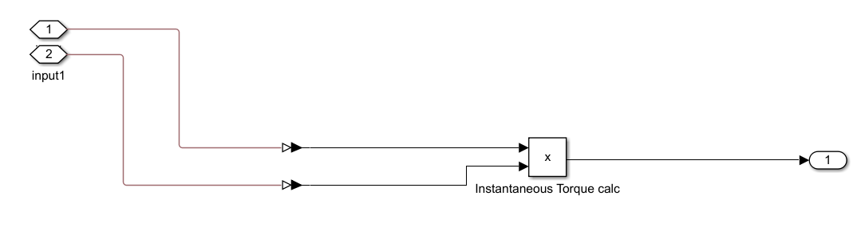
3. Instantaneous Torque Calc
Figure 4: Block Diagram of Instantaneous Torque Calc
Just takes the instantaneous actuator torque and angular velocity of the flywheel and multiplies them to get the output of the instantaneous power output. This output is then connected to a scope which gives the average and rms values of the same.
Some values are tabulated below for the current parameters(the ones entered in the same commit as the one that contains this doc file) with some variations on the CV of the fuel used:
Angular Speed Set (in rad/s) | Mean Power (in KW) | RMS Power (in KW)
600 | -2.629 x 10^4 | 1.471 x 10^5
700 | -2.279 x 10^4 | 1.703 x 10^5
800 | -1.695 x 10^4 | 1.937 x 10^5
900 | -9.695 x 10^3 | 2.173 x 10^5
1000 | -7.431 x 10^1 | 2.412 x 10^5
1001.5625 | 4.332 x 10^2 | 2.415 x 10^5
1003.125 | 5.775 x 10^2 | 2.419 x 10^5
1006.25 | 1.020 x 10^3 | 2.427 x 10^5
1012.5 | 1.179 x 10^3 | 2.442 x 10^5
1025 | 3.294 x 10 ^3 | 2.472 x 10^5
1050 | 5.967 x 10^3 | 2.533 x 10^5
1100 | 1.201 x 10^4 | 2.656 x 10^5

Observe that the +ve output power appears between 1000 rad/s and 1001.5625 rad/s keeps increasing after that. Negative values represent the fact that the assembly requires external power to run under the given constraints.

Conclusions
A complete simulation of a single-cylinder 4-stroke CI engine was successfully created using MATLAB R2024b. The model replicates the physical motion of the Flywheel–Crankpin–Connecting Rod–Piston assembly and produces outputs for instantaneous torque, power, and other physical quantities related to the generator setup.
However, the results obtained are not fully accurate. A major issue lies in the pressure signal generation method — in the current setup, a simple sawtooth pulse is used, which does not resemble the real pressure–crank angle curve of a CI engine. Real engines show a much smoother and delayed pressure rise and fall after ignition. The simulation also ignores losses such as heat transfer, viscous drag, and friction since no air mass or combustion gases are actually modeled. Another simplification is assuming that the entire cylinder volume is filled with the air–fuel mixture, which is not true in practice.
Some bugs or inconsistencies may also occur due to the initialization script. Apart from checking the Grashof condition, there are no limits on the input parameters, so most combinations of values will cause unrealistic or unstable behaviour. Only a small range of parameter combinations currently gives meaningful results.
Even with these issues, the project achieves its main goal, to simulate the mechanical motion and basic working of a CI generator.

